CrowdEase — Test Case Document
Integration & QA · Happy Path + Negative Test · Semua titik integrasi (TI-1 s/d TI-4)

Metric | Value
Total Test Cases | 26
Happy Path | 14
Negative Test | 12
Titik Integrasi (TI) | 4

TI-1 · IoT Sensor Integration
Titik integrasi untuk data yang dikirimkan oleh sensor IoT pada armada bus.

TC-1-01 · Happy Path: Kirim data sensor valid
Deskripsi: Sensor berhasil mencatat kepadatan bus.
Endpoint: POST /api/v1/sensors/readings
Prasyarat: API key aktif tersedia, vehicle_id = 1 ada di database.
Request:
Header: X-API-Key: {api_key_valid}
Body: {
"vehicle_id": 1,
"passenger_count": 30,
"capacity_at_time": 50,
"recorded_at": "2026-06-03T10:00:00Z"
}
Expected Response:
Status: 201 Created
{
"success": true,
"occupancy_ratio": 0.600,
"occupancy_level": "medium",
"forecast_triggered": true / false
}
Actual Response:
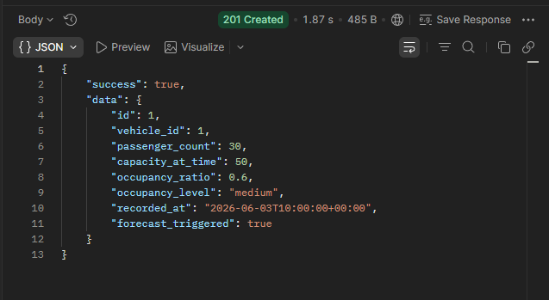

Status:
Pass

TC-1-02 · Happy Path: Smoke-test API key valid
Deskripsi: GET /sensors/check mengembalikan nama key.
Endpoint: GET /api/v1/sensors/check
Request:
Header: X-API-Key: {api_key_valid}
Expected Response:
Status: 200 OK
{
"success": true,
"data": {
"message": "API key valid",
"key_name": "nama key sesuai DB"
}
}

Actual Response:
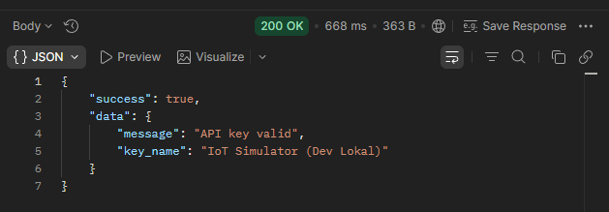

Status:
Pass

TC-1-03 · Happy Path: Occupancy level = "high" (ratio 0.9)
Deskripsi: Pastikan threshold kepadatan tinggi benar.
Endpoint: POST /api/v1/sensors/readings
Request:
Header: X-API-Key: {api_key_valid}
Body: {
"vehicle_id": 1,
"passenger_count": 45,
"capacity_at_time": 50,
"recorded_at": "2026-06-03T10:05:00Z"
}
Expected Response:
Status: 201 Created
{
"occupancy_ratio": 0.900,
"occupancy_level": "high"
}

Actual Response:
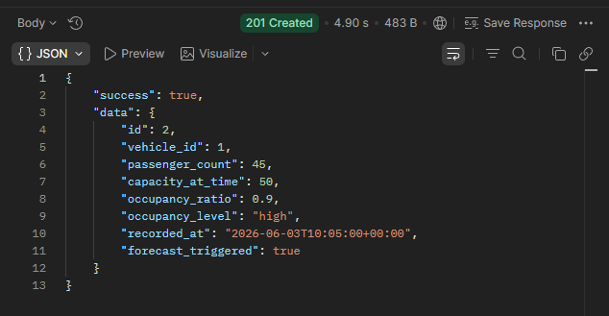
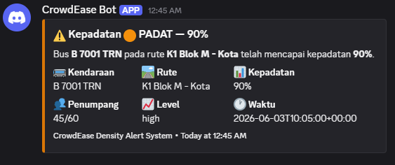

Status:
Pass

TC-1-04 · Negative Test: Kirim tanpa header X-API-Key
Deskripsi: Request harus ditolak 401.
Endpoint: POST /api/v1/sensors/readings
Request:
Header: (tidak ada X-API-Key)
Body: { "vehicle_id": 1, "passenger_count": 10, "capacity_at_time": 50, "recorded_at": "..." }
Expected Response:
Status: 401 Unauthorized
{
"success": false,
"error": {
"code": "UNAUTHORIZED",
"message": "Header X-API-Key wajib disertakan."
}
}

Actual Response:
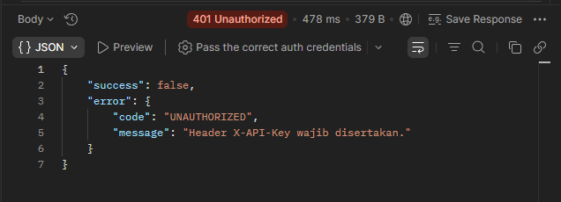

Status:
Pass

TC-1-05 · Negative Test: API key salah / dicabut
Deskripsi: Key tidak ada di DB atau revoked_at tidak null.
Endpoint: POST /api/v1/sensors/readings
Request:
Header: X-API-Key: invalid-key-xyz
Expected Response:
Status: 401 Unauthorized
{
"error": {claude "code": "UNAUTHORIZED",
"message": "API key tidak valid atau sudah dicabut."
}
}

Actual Response:
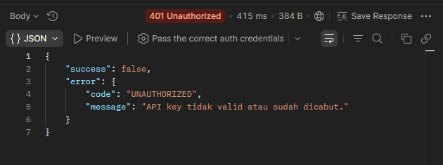

Status:
Pass

TC-1-06 · Negative Test: vehicle_id tidak ada di database
Deskripsi: Validasi exists:vehicles,id gagal.
Endpoint: POST /api/v1/sensors/readings
Request:
Header: X-API-Key: {valid}
Body: {
"vehicle_id": 99999,
"passenger_count": 10,
"capacity_at_time": 50,
"recorded_at": "2026-06-03T10:00:00Z"
}
Expected Response:
Status: 422 Unprocessable Entity
{
"error": {
"details": {
"vehicle_id": "Kendaraan dengan ID tersebut tidak ditemukan."
}
}
}

Actual Response:
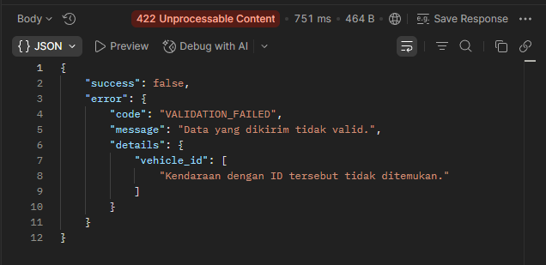

Status:
Pass

TC-1-07 · Negative Test: recorded_at lebih dari 5 menit ke depan
Deskripsi: Toleransi clock skew dilampaui.
Endpoint: POST /api/v1/sensors/readings
Request:
Header: X-API-Key: {valid}
Body: {
"vehicle_id": 1,
"passenger_count": 10,
"capacity_at_time": 50,
"recorded_at": "2030-01-01T00:00:00Z"
}
Expected Response:
Status: 422 Unprocessable Entity
{
"error": {
"details": {
"recorded_at": "Waktu pencatatan tidak boleh lebih dari 5 menit ke depan."
}
}
}

Actual Response:
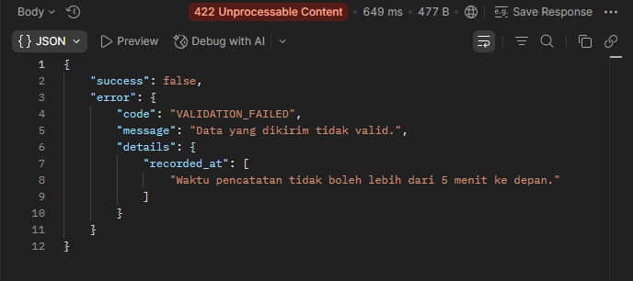

Status:
Pass

TI-2 · Webhook Integration
Manajemen dan pengujian sistem penyebaran webhooks ke sistem eksternal.

TC-2-01 · Happy Path: Buat webhook baru
Deskripsi: Simpan webhook dengan semua field valid.
Endpoint: POST /api/v1/admin/webhooks
Prasyarat: Sudah login, bearer token valid (dapatkan melalui TC-4-01 terlebih dahulu).
Request:
Header: Authorization: Bearer {token}
Body: {
"name": "Notifikasi Discord OPS",
"url": "https://webhook.site/test-abc",
"events": ["density.alert", "density.critical"],
"secret": "mysecretkey123"
}
Expected Response:
Status: 201 Created
{
"success": true,
"data": {
"name": "Notifikasi Discord OPS",
"is_active": true,
"events": ["density.alert", "density.critical"]
}
}

Actual Response:
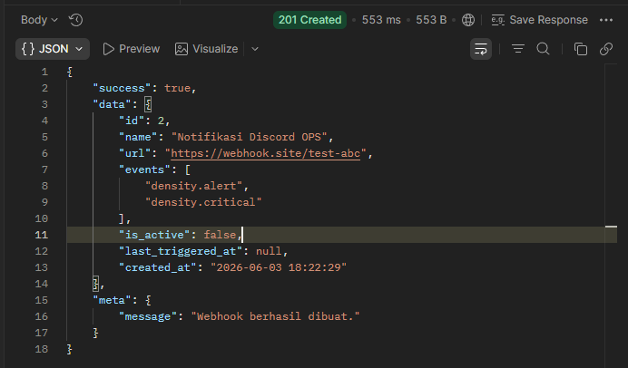

Status:
Pass

TC-2-02 · Happy Path: Kirim test payload ke webhook
Deskripsi: POST .../test memicu pengiriman ke URL tujuan.
Endpoint: POST /api/v1/admin/webhooks/{id}/test
Prasyarat: Webhook dengan {id} sudah dibuat dan is_active = true.
Request:
Header: Authorization: Bearer {token}
Body: (kosong)
Expected Response:
Status: 200 OK
{
"data": {
"webhook_id": "{id}",
"url": "URL tujuan webhook",
"verifikasi": "webhook.site / Discord menerima payload"
}
}

Actual Response:
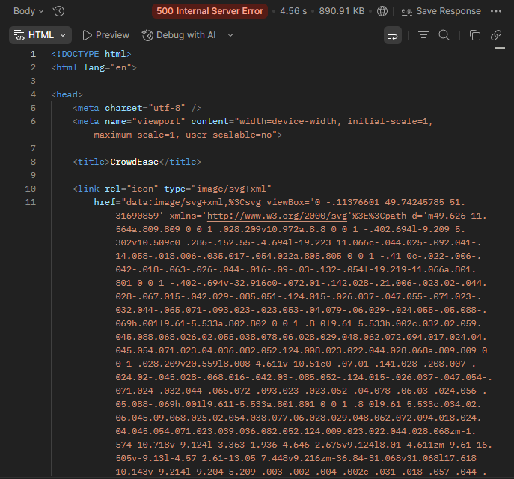
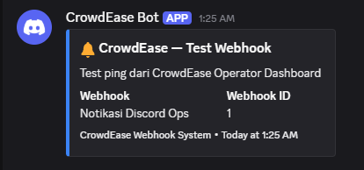

Status:
Fail, di postman mengeluarkan gagal tapi di discord berhasil

TC-2-03 · Happy Path: Update URL dan event webhook
Deskripsi: PUT berhasil memperbarui data.
Endpoint: PUT /api/v1/admin/webhooks/{id}
Request:
Header: Authorization: Bearer {token}
Body: {
"url": "https://webhook.site/updated-url",
"is_active": false
}
Expected Response:
Status: 200 OK
{
"data": {
"url": "https://webhook.site/updated-url",
"is_active": false
}
}

Actual Response:
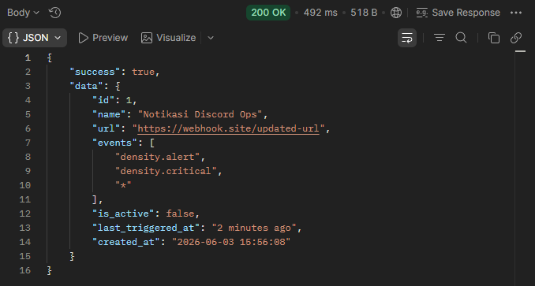

Status:
Pass, tapi ketika diubah id nya tidak tetap tapi id + 1

TC-2-04 · Happy Path: Hapus webhook
Deskripsi: DELETE menghapus dan mengembalikan deleted_id.
Endpoint: DELETE /api/v1/admin/webhooks/{id}
Request:
Header: Authorization: Bearer {token}
Expected Response:
Status: 200 OK
{
"data": {
"deleted_id": "{id} yang dihapus"
}
}

Actual Response:
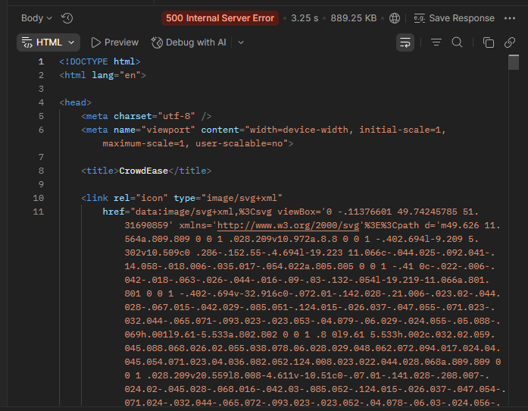
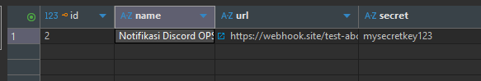

Status:
Fail, sebelum uji coba postman ini ada webhooks dengan id 3 di database berjalan tapi di postman mengeluarkan 500

TC-2-05 · Negative Test: Buat webhook tanpa token
Deskripsi: Request tanpa Authorization header.
Endpoint: POST /api/v1/admin/webhooks
Request:
Header: (tidak ada Authorization)
Body: { "name": "X", "url": "https://webhook.site/x" }
Expected Response:
Status: 401 Unauthorized
{
"success": false
}

Actual Response:
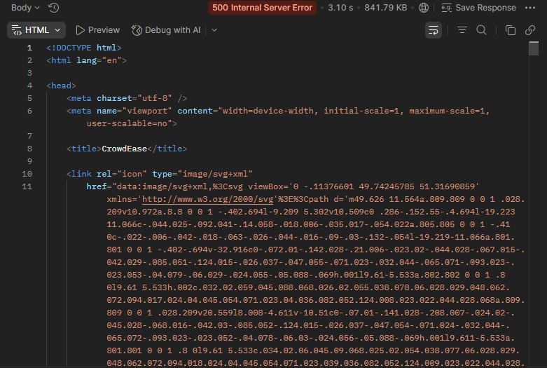

Status:
Fail, di dalam kode masih belum ada atau ditambahkan jika tanpa authorization

TC-2-06 · Negative Test: URL tidak valid saat buat webhook
Deskripsi: Field url bukan format URL yang benar.
Endpoint: POST /api/v1/admin/webhooks
Request:
Header: Authorization: Bearer {token}
Body: {
"name": "Test",
"url": "bukan-url-valid"
}
Expected Response:
Status: 422 Unprocessable Entity
{
"error": {
"details": {
"url": "pesan validasi url"
}
}
}

Actual Response:
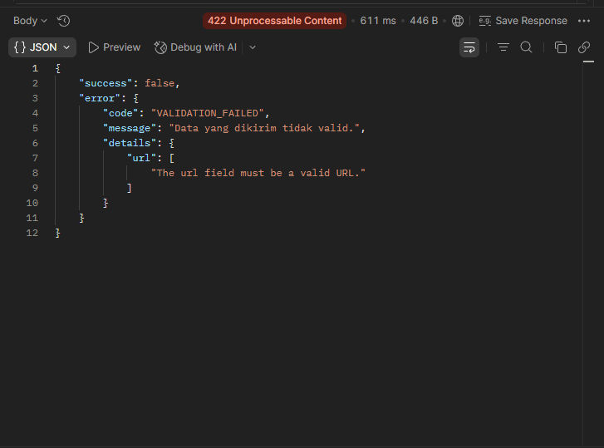

Status:
Pass

TC-2-07 · Negative Test: Test webhook dengan ID tidak ada
Deskripsi: POST .../99999/test harus 404.
Endpoint: POST /api/v1/admin/webhooks/99999/test
Request:
Header: Authorization: Bearer {token}
Expected Response:
Status: 404 Not Found
{
"success": false
}

Actual Response:
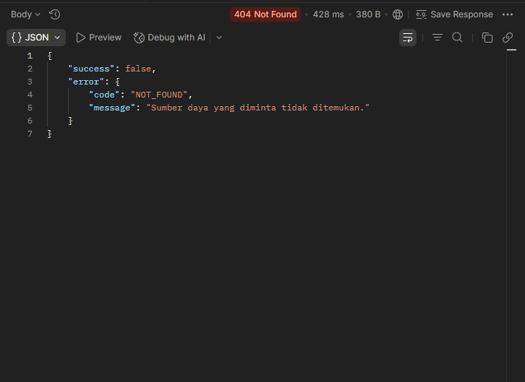

Status:
Pass

TI-3 · Passenger API
Endpoint publik yang digunakan oleh aplikasi penumpang untuk mendapatkan informasi kepadatan armada real-time.

TC-3-01 · Happy Path: Health check ping
Deskripsi: GET /ping mengembalikan pong tanpa auth.
Endpoint: GET /api/v1/ping
Request:
Header: (tidak perlu auth)
Expected Response:
Status: 200 OK
{
"data": {
"message": "pong",
"service": "CrowdEase API",
"time": "ISO 8601 timestamp"
}
}

Actual Response:
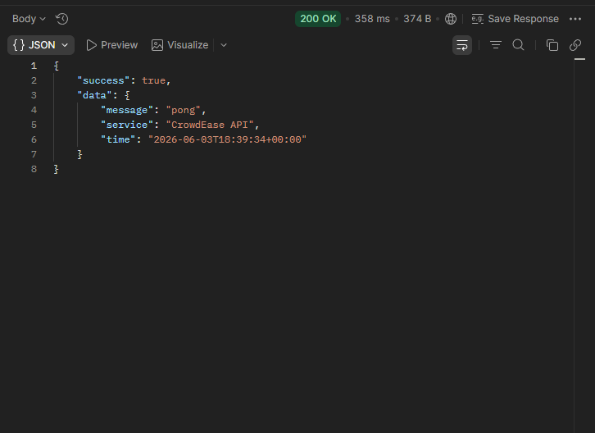

Status:
Pass

TC-3-02 · Happy Path: Daftar semua koridor aktif
Deskripsi: GET /routes hanya kembalikan koridor is_active=true.
Endpoint: GET /api/v1/routes
Request:
Header: Accept: application/json
Expected Response:
Status: 200 OK
{
"data": [
// array koridor diurutkan berdasarkan code.
// Tiap item memiliki stops_count & vehicles_count.
// Koridor dengan is_active=false tidak akan muncul.
]
}

Actual Response:

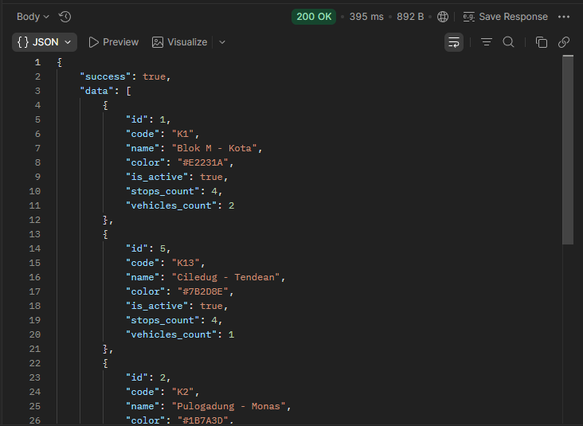

Status:
Pass

TC-3-03 · Happy Path: Armada aktif dalam koridor + kepadatan terkini
Deskripsi: GET /routes/{id}/vehicles untuk polling penumpang.
Endpoint: GET /api/v1/routes/{route_id}/vehicles
Request:
Header: Accept: application/json
Expected Response:
Status: 200 OK
{
"meta": {
"server_time": "ISO 8601 timestamp"
},
"data": [
// array armada dengan status=active yang memiliki field occupancy_level
]
}

Actual Response:
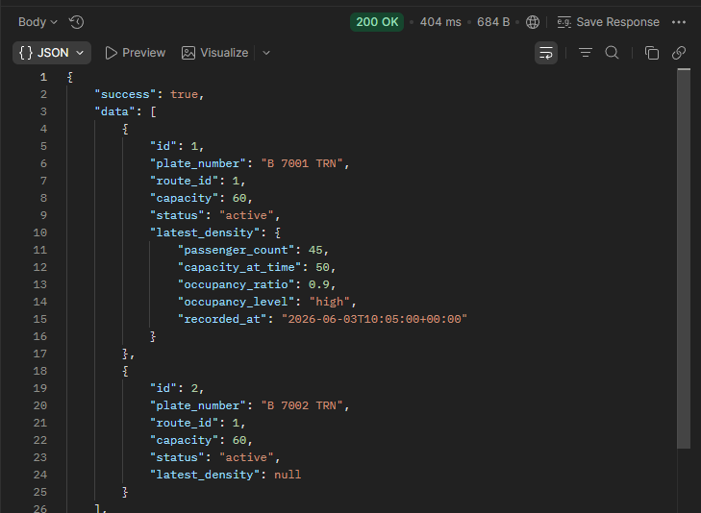

Status:
Pass

TC-3-04 · Happy Path: Riwayat kepadatan default 30 menit
Deskripsi: GET density/history tanpa query param.
Endpoint: GET /api/v1/vehicles/{id}/density/history
Request:
Header: Accept: application/json
Query: (tidak ada query param)
Expected Response:
Status: 200 OK
{
"data": {
"window_minutes": 30,
"logs": [ /* array, max 500 item */ ]
}
}

Actual Response:
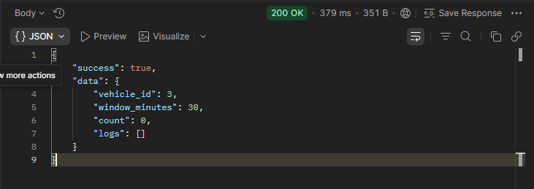

Status:
Pass

TC-3-05 · Negative Test: Koridor tidak ditemukan
Deskripsi: GET /routes/99999 harus 404.
Endpoint: GET /api/v1/routes/99999
Request:
Header: Accept: application/json
Expected Response:
Status: 404 Not Found
{
"success": false
}

Actual Response:
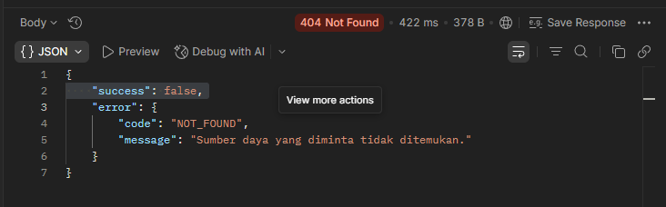

Status:
Pass

TC-3-06 · Negative Test: Parameter minutes di luar batas (0 / 999)
Deskripsi: Clamp ke range 1-180, bukan murni error response. Controller otomatis melakukan clamp: max(1, min(180, $minutes)).
Endpoint: GET /api/v1/vehicles/{id}/density/history?minutes=999
Expected Response:
Status: 200 OK
{
"data": {
"window_minutes": 180 // Nilai 999 otomatis di-clamp ke 180, tidak mengembalikan error
}
}

Actual Response:
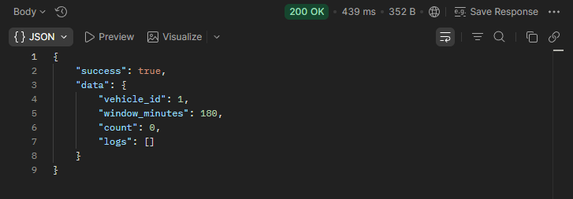

Status:
Pass

TI-4 · Admin CRUD & Backoffice
Endpoint operasional internal untuk mengelola armada, rute/koridor, serta autentikasi petugas.

TC-4-01 · Happy Path: Login operator berhasil
Deskripsi: Mendapatkan bearer token Sanctum.
Endpoint: POST /api/v1/admin/auth/login
Request:
Body: {
"email": "operator@crowdease.test",
"password": "secret123",
"device_name": "QA Browser"
}
Expected Response:
Status: 200 OK
{
"data": {
"token": "string (Sanctum plain text token)",
"token_type": "Bearer",
"user": {
"email": "operator@crowdease.test"
}
}
}

Actual Response:
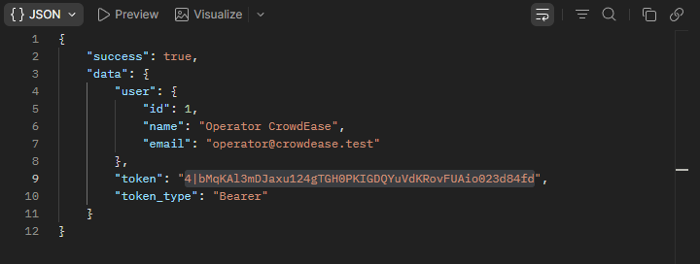

Status:

TC-4-02 · Happy Path: Buat armada baru
Deskripsi: POST /vehicles dengan data lengkap.
Endpoint: POST /api/v1/admin/vehicles
Request:
Header: Authorization: Bearer {token}
Body: {
"route_id": 1,
"plate_number": "B 1234 ZZQ",
"capacity": 80
}
Expected Response:
Status: 201 Created
{
"data": {
"plate_number": "B 1234 ZZQ",
"status": "active" // default value
}
}

Actual Response:
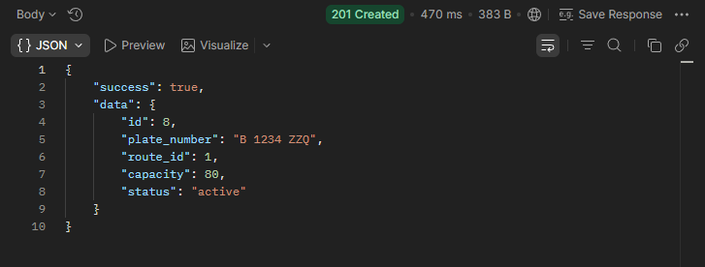

Status:

TC-4-03 · Happy Path: Buat koridor baru
Deskripsi: POST /routes dengan kode unik dan warna hex.
Endpoint: POST /api/v1/admin/routes
Request:
Header: Authorization: Bearer {token}
Body: {
"code": "1A",
"name": "Koridor 1A Blok M - Kota",
"color": "#E11D2A"
}
Expected Response:
Status: 201 Created
{
"data": {
"code": "1A",
"is_active": true // default value
}
}

Actual Response:
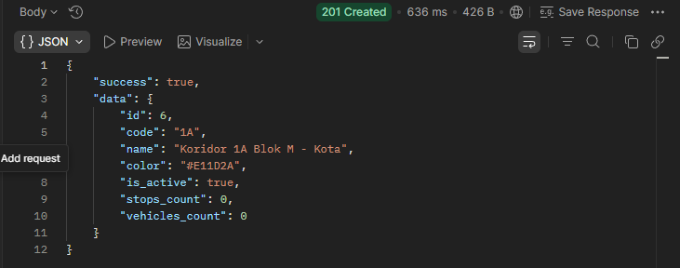

Status:
Pass

TC-4-04 · Happy Path: Hapus armada tanpa riwayat sensor
Deskripsi: DELETE berhasil jika belum ada density_logs.
Endpoint: DELETE /api/v1/admin/vehicles/{id}
Prasyarat: Vehicle baru yang belum punya density_logs atau forecasts.
Expected Response:
Status: 200 OK
{
"data": {
"deleted_id": "{id} yang dihapus"
}
}

Actual Response:
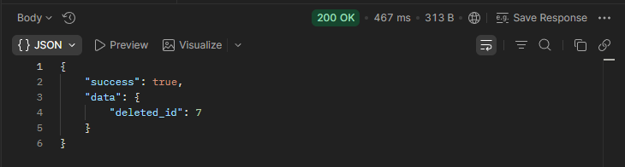

Status:
pass

TC-4-05 · Negative Test: Login dengan password salah
Deskripsi: Pesan error generik, tidak mengekspos spesifik "email tidak ditemukan".
Endpoint: POST /api/v1/admin/auth/login
Request:
Body: {
"email": "operator@crowdease.test",
"password": "salahpassword"
}
Expected Response:
Status: 401 Unauthorized
{
"error": {
"code": "INVALID_CREDENTIALS",
"message": "Email atau password salah."
}
}

Actual Response:
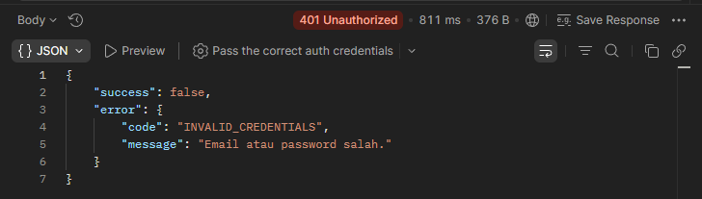

Status:
Pass

TC-4-06 · Negative Test: Nomor plat duplikat
Deskripsi: Aturan unique:vehicles,plate_number harus menolak entri duplikat.
Endpoint: POST /api/v1/admin/vehicles
Prasyarat: Plate "B 1234 ZZQ" sudah terdaftar di DB (dari TC-4-02).
Request:
Header: Authorization: Bearer {token}
Body: {
"route_id": 1,
"plate_number": "B 1234 ZZQ",
"capacity": 60
}
Expected Response:
Status: 422 Unprocessable Entity
{
"error": {
"details": {
"plate_number": "Nomor plat sudah terdaftar."
}
}
}

Actual Response:
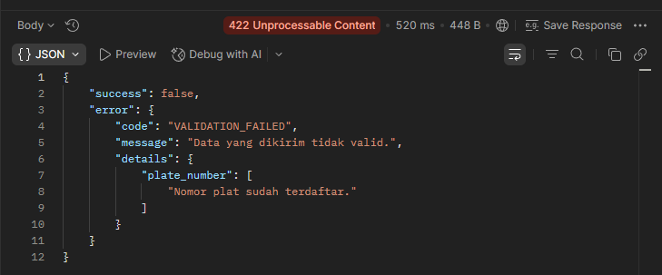

Status:
Pass

TC-4-07 · Negative Test: Hapus armada yang punya riwayat sensor
Deskripsi: Harus ditolak 409 HAS_DEPENDENCIES untuk menjaga integritas data.
Endpoint: DELETE /api/v1/admin/vehicles/{id}
Prasyarat: Vehicle {id} sudah punya minimal 1 baris data di tabel density_logs.
Expected Response:
Status: 409 Conflict
{
"error": {
"code": "HAS_DEPENDENCIES",
"details": {
"hint": "saran set status=\"inactive\""
}
}
}

Actual Response:
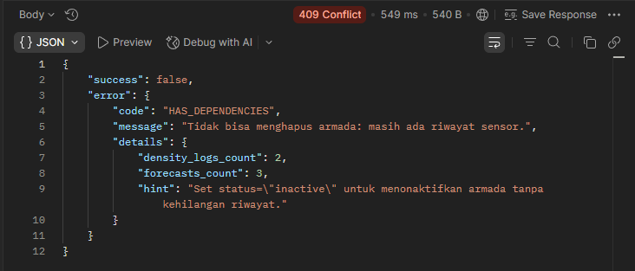

Status:
Pass

TC-4-08 · Negative Test: Warna koridor bukan format hex
Deskripsi: Regex /^#[0-9A-Fa-f]{6}$/ harus mendeteksi format yang salah.
Endpoint: POST /api/v1/admin/routes
Request:
Header: Authorization: Bearer {token}
Body: {
"code": "2B",
"name": "Koridor 2B",
"color": "red"
}
Expected Response:
Status: 422 Unprocessable Entity
{
"error": {
"details": {
"color": "Format warna harus hex (mis. #E11D2A)."
}
}
}

Actual Response:
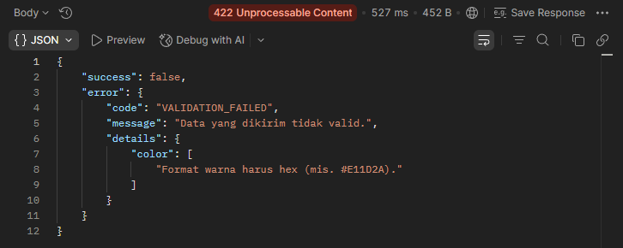

Status:
Pass

